ABAP/4
ABAP Part I LAB BOOK

Table of Contents
Table of Contents 2
Getting Started 4
Lab 1-1 Introduction to ABAP Progarmming 5
Lab 2-1 Data Dictionary 6
Lab 3-1 Internal tables 10
Lab 4-1 Advanced Internal tables 11
Lab 5-1 String Operations 14
Lab 6-1 Common Control Statements 18
Lab 7-1 Modularization Techniques 19
Lab 8-1 Interactive List Events 20

Getting Started

Overview
This lab book is a guided tour for learning SAP ABAP. It comprises of assignments to be done. Refer the demos and work out the assignments given by referring the case studies which will expose you to work with Java applications.

Setup Checklist for SAP ABAP
Here is what is expected on your machine in order to work with lab assignment.
Minimum System Requirements
- Intel Pentium 90 or higher (P166 recommended)
- Microsoft Windows 7 or higher.
- Memory: (1GB or more recommended)

Please ensure that the following is done:
- SAP GUI is installed
- Connection to the SAP Server is present

Lab 1-1 Introduction to ABAP Progarmming
Goals | - Create simple programs in ABAP editor
Time | 60 Minutes
Lab Setup | Connectivity to SAP server  Login details for connecting to SAP server

1. Write a program to display the Empid, EmpName, Emp_addr in chain statement using write.

Hint: All the variable should be in declared using DATA statement.

2. Write a program to display the System Date, System Time, Current User ID,Current report name by using single write statement.

3. Write a program to display the first 10 passengers from sbook table. Consider any 10 fields to display the output.

4. Write a program to display the data from sbook table. The data should be filtered by airline and ordered by customid.
The airline should be accepted through parameters or select-options.
Consider any 10 fields to display the output.

Use Select .. EndSelect in 3 and 4.
After that, use internal tables also in 3 and 4.

Lab 2-1 Data Dictionary

Goals | - Create Tables, Views and Search Helps
Time | 60 Minutes
Lab Setup | Connectivity to SAP server  Login details for connecting to SAP server

- Create the tables with the following structure. Name of the table as z_xxxxxx_emp.
Where xxxxx is your empcode.
z_xxxxxx_emp
Field Name | Data Element | Domain | Domain Data Type and length
EMPNO (PK) | Z_XX_DEEMPNO | Z_XX_DEMPNO | NUMC 4
ENAME | Z_XX_DEENAME | Z_XX_DENAME | CHAR 10
JOB | Z_XX_DEJOB | Z_XX_DJOB | CHAR 9
MGR | Z_XX_DEMGR | Z_XX_DMGR | NUMC 4
HIREDATE | Z_XX_DEHIREDATE | Z_XX_DHIREDATE | DATS
SAL | Z_XX_DESAL | Z_XX_DSAL | DECIMAL 7 2
COMM | Z_XX_DECOMM | Z_XX_DCOMM | DECIMAL 7 2
DEPTNO (FK) | Z_XX_DEDEPTNO | Z_XX_DDEPTNO | NUMC 2

z_xxxxxx_dept
Field Name | Data Element | Domain | Domain Data Type and length
DEPTNO(PK) | Z_XX_DEDEPTNO | Z_XX_DEDEPTNO | NUMC 2
DNAME | Z_XX_DEDNAME | Z_XX_DEDNAME | CHAR 14
LOC | Z_XX_DELOC | Z_XX_DELOC | CHAR 13

Note: Data Element and Domains for deptno field is the same in both tables.

z_xxxxxx_salgrade
Field Name | Data Element | Domain | Domain Data Type and length
GRADE | Z_XX_DEGRADE | Z_XX_DGRADE | NUMC 2
LOSAL | Z_XX_DELOSAL | Z_XX_DLOSAL | DECIMAL 7 2
HISAL | Z_XX_DEHISAL | Z_XX_DHISAL | DECIMAL 7 2

Where:
1) XXXXXX is your empcode

This is to ensure uniqueness of your table name, domain and data element name.

- Write down an ABAP program to insert the following records in the Dept table.
Use Internal Table to insert the records.

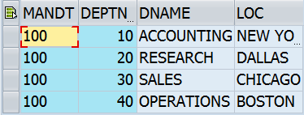

- Write down an ABAP program to insert the following records in the Emp table.
OR Use Table Maintainance generator/Internal table to insert records.

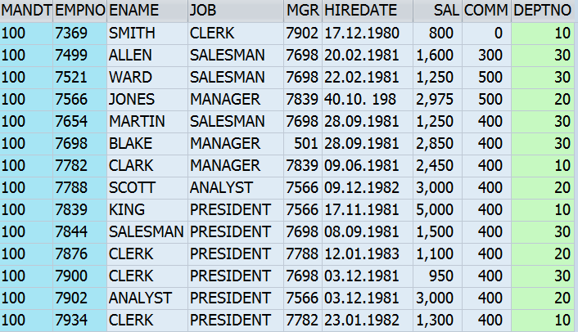

- Create an ABAP program as per the following specifcations:

ABAP Inputs:

The ABAP program will have parameters for employee number , employee name and salary with the definitions as per the database table fields.

Screen Validations

Mandatory input for all parameters.
Employee name should not be blank and Salary cannot be zero.

Employee number can contain only numbers.

Main Processing Logic :

Read the Emp table created above using the Employee number, which has been input.

If matching entry exists, then check the input name and salary. If at least one of them is different than db record, then record should be modified with changed values.

If matching entry for the accepted Employee number does not exist, new entry should be created in table with input values. You may hardcode the values for remaining fields(Job, Mgr, Hiredate, Comm, Deptno) here.

Output Format:

If record has been modified, display ‘Record Updated’.

If record has been added, display ‘Record added’.

Test Conditions

Report should be run with values for which entries exists in the db and also new values for which entries do not exist, so that both addition and modification of records can be tested.

Error checking: If employee code contains characters other then numbers, then suitable error message should be displayed. (Define Text elements for message text).

Hints

For the above program ABAP make use of following:

SELECT, INSERT, UPDATE.

- Create a copy of the above assignment. Use only MODIFY instead of INSERT/UPDATE.

- Create two ztables (Eg: ZXXX_SCARR, ZXXX_SPFLI) by using predefined table fields of SCARR AND SPFLI. Select at least 5 fields from each table and load some data into that two ztables.

Note: To enter the data/entries to ZTables Ref: SCARR and SPFLI tables content/entries.

Step # 2: Maintain foreign key between the two ztables.

Step # 3: Create the data base view for the above two ztables.

Step # 4: Write an ABAP code and get the data from the database view (from the step # 3) and display the output.

- Create help view and search help.

Step # 1: Create two ztables (Eg: ZXXX_SFLIGHT, ZXXXX_SBOOK) by using predefined table fields of SFLIGHT AND SBOOK. Select at least 5 fields from each table and load some data into that two ztables.

Step # 2: Maintain foreign key between the two ztables.

Step # 3: Create the help view for the above two ztables.

Step # 4: Create the elementary search help and provide the help view name in the selection method of search help.

Step # 5: Attach the search help to the primary keys of the both the ztables.

- Create a maintainance view based on ZXXX_SFLIGHT, ZXXXX_SBOOK tables created above.
Use the Table Maintainance generator to see if records can be inserted in the base table ZXXX_SFLIGHT, ZXXXX_SBOOK though the maintainance view.

Lab 3-1 Internal tables

Goals | - Retrive records from Internal Table
Time | 60 Minutes
Lab Setup | Connectivity to SAP server  Login details for connecting to SAP server

- Write an ABAP program which will retrieve 20 records of the DB table SBOOK and insert in it a Standard Internal table. Name the internal table as itsbook. Do not define any key for the internal table.
Retrieve only the following fields carrid, connid,fldate,bookid,customid,Airline currency, booking date,passenger name
Write separate subroutines to :
- Display all records from the internal table
- Display only records from 2 to 5
- Display the 5th Record
- Display the record where name of passenger is Adam Heller
- Modify the ename of the 5th Record as Steve
- Delete the record where ename is Adam Heller
- Delete the 10th Record
- Delete records from 12 to 16

In all the above cases display all the records after perform each of the above tasks.

- Create a copy of the above assignment. Modify the above internal table to define the key as passenger name.
Retrieve the record with passenger name is Adam Heller.
Hint: Use the table key clause

- Create a copy of Assignment1. Declare the table as a sorted table and perform all the operations as mentioned in it.

- Create a copy of the above assignment1. Declare the table as a hashed table and perform all the operations as mentioned in it. Note your observations.

Lab 4-1 Advanced Internal tables

Goals | - Use control break logic to display data from Internal table and other commands. To work with an Internal table commands INSERT, INSERT Multiple, UPDATE, MODIFY and DELETE.
Time | 60 Minutes
Lab Setup | Connectivity to SAP server  Login details for connecting to SAP server

- Create an ABAP program to display output as shown below.
Hint: Use At First, At Last. Retreive records from DB table SPFLI.

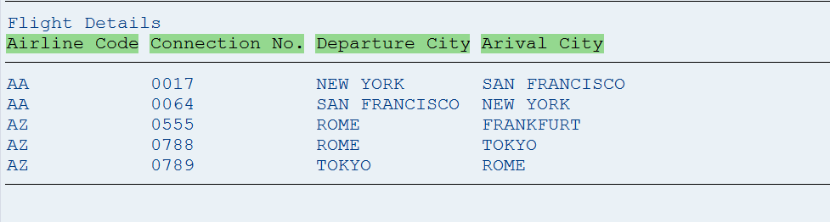

- Create an ABAP program to display output as shown below.
Hint: Use At First, At Last, At New. Retreive records from DB table SPFLI.
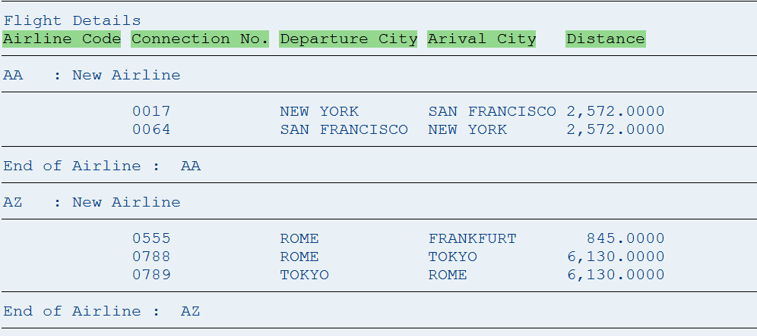

- Create an ABAP program to display output as shown below.

Hint: Use At First, At Last, At New, Sum. Retreive records from DB table SPFLI.

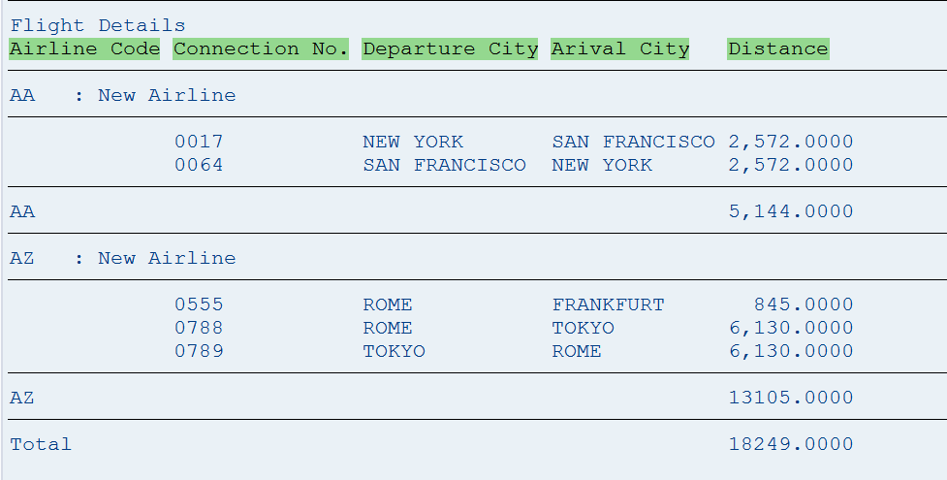

- Create an ABAP program to display output as shown below.

Hint: Use At First, At Last, At New, On Change. Retreive records from DB table SPFLI.

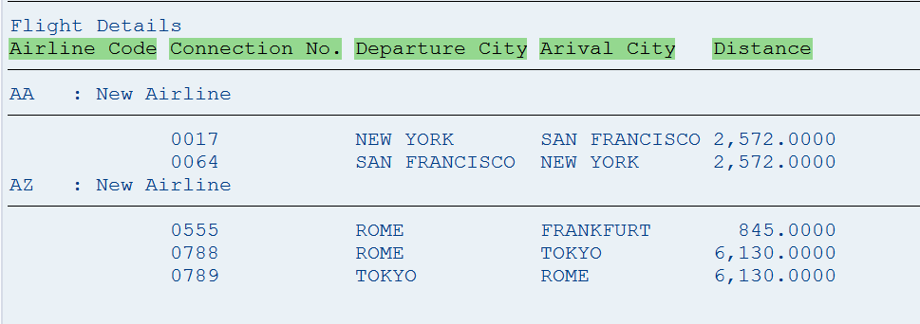

- Create an ABAP program to display output as shown below.

Hint: Use At First, At Last, At New, On Change. Retreive records from DB table SPFLI
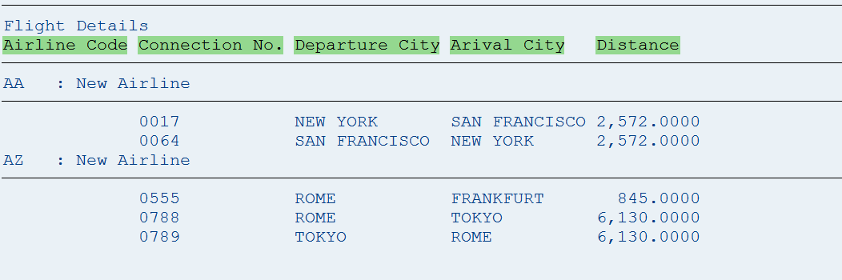

- Create an ABAP program to display data from SPFLI(carrid, connid) and SFLIGHT(carrid, connid, fldate) table.
The program should accept the cityfrom from the SPFLI table and display the corresponding records from the SFLIGHT table. Use joins.

- Create an ABAP program to display data from SPFLI(carrid, connid) and SFLIGHT(carrid, connid, fldate) table.
The program should accept the cityfrom from the SPFLI table and display the corresponding records from the SFLIGHT table. Use FOR ALL ENTRIES.

Lab 5-1 String Operations
Goals | - Create an ABAP Program for String Operations
Time | 90 Minutes
Lab Setup | Connectivity to SAP server  Login details for connecting SAP server

1. Create an ABAP Program with the following parameters.

P_STRING1 - input string. The input should be taken in LOWERCASE.
FLAGS should be displayed as radiobutton. Depending upon the value of the selected FLAG, corresponding function will be performed on the input string.

T_FLAG – to convert the string to UPPERCASE
L_FLAG – to return the length of the string
S_FLAG – to remove leading zeroes in the string
O_FLAG – to return subset of string starting from offset P_OFFSET and having length P_LENGTH.

P_OFFSET and P_LENGTH are parameters to take in the offset and length of the substring.

Screen Validations

Offset and Length should be numeric.

In case O_Flag not set, both offset and length must be 0.
O_Flag set, at least length must be non-zero positive value.
O_Flag set, then offset + length should be <= length of string.
S_Flag set, then string must contain leading zeroes.

Main Processing Logic:

Depending upon the FLAG, corresponding operation should be performed on the string.

Output Format:

If there is an error during validations, suitable error message should be displayed.
Or If the validations are successful, then the resultant string should be displayed after the operation is performed.

Test Conditions

Testing should be performed for all values of flag.

Error checking: Check out all scenarios where error will occur and check whether appropriate error message is displayed or not (Define text elements for message text).

Hints:
For this ABAP make use of following:
RADIOBUTTON GROUP, TRANSLATE, STRLEN, SHIFT.
Use subroutines for performing each of the operations.
2. Create an ABAP program with the following parameters.

Define P_STRING – input string default value .
‘000000000075001234, Material No: 000000000014634566, 53’.

Screen-validations:

Check if atleast 1 comma exists in the input string.

Main Processing Logic:

Split the input string at comma into 3 different variables.

Search 2nd of these variables for string ‘Material No:’.

Move the Material no. into another variable.

Output Format:

Write the extracted material no. to the screen.

Hints:

Use SPLIT, SEARCH, STRLEN, commands

3. Create an ABAP Program.

It will have following parameters.

Provide String_1 and String_2 value as a default in the program and user can change the values at runtime with own input values.

Screen-validations:

Check atleast one space should be exists in the input value of string_1.
String_1 and String_2 should be obligatory.

Main Processing Logic:

Accept two input strings (String_1 and String_2) from the user at rutime by using parameters and display these two string values at the list output as a heading.

Hints:

# 1. Use CONCATENATE, TRANSLATE, CONDENSE, NO-GAPS, STRING LENGTH, SHIFT AND
SHIFT BY PLACES commands to display the main logic.

# 2. Use split command by using Internal tables .

Input Format: Format of the input screen like below with proper text and title by using the text elements and list headings.

Input Screen:
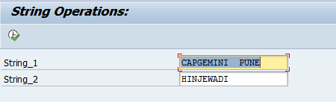

Output Format: the output format should be like as shown below.
Output Screen:
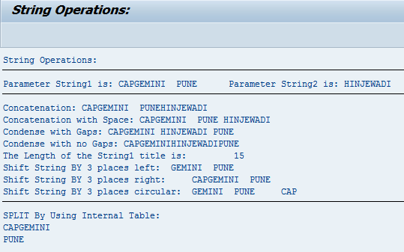

Lab 6-1 Common Control Statements

Goals | - Use common control statements
Time | 60 Minutes
Lab Setup | Connectivity to SAP server  Login details for connecting to SAP server

- Write an ABAP program to calculate the Grade of the students, based on the input marks.

- If the input Marks are > 90 - Grade 5.
- If the input Marks are between 80 and 90 – grade 4.
- If the input Marks are between 70 and 80 – grade 3 .
- If the input Marks are between 60 and 70 – grade 2
- If the input Marks are < 60 grade 0.

Lab 7-1 Modularization Techniques
Goals | - How to Create the Function Group and Function Modules.  - How to Create and Call the Subroutines.
Time | 60 Minutes
Lab Setup | Connectivity to SAP server  Login details for connecting to SAP server

- Create a simple program which accepts a material number. Write a subroutine which passes the material number by value and displays the following details regarding in the subroutine:
Material Number
Industry Sector
Material Type
Base UOM
Gross weight
Net Weight

- Passing Parameters by Reference
Make a copy of the above program and pass the material number by reference. Change the material number in the subroutine and display the details in the main program.

- Passing Structures
Create a simple program which accepts a material number. Write down a select query in the program which retrieves details of the Material Number in the structure.
Create a subroutine which receives the structure and displays the data.
Hint: Use Select Single to retrieve a single record

- Passing Internal Tables
Create a simple program which accepts a material number. Write down a select query in the program which retrieves details of the Material Number in the internal table.
Create a subroutine which receives the internal table and displays the data.
Note: Do various options of declaring internal table with/without header line.

- Do assignment1 using fucntion Module. An ABAP program accepts a Material number and passes it to a function module. The function module returns the below details to the ABAP program.
Industry Sector ,Material Type, Base UOM , Gross weight, Net Weight
The ABAP program then displays the details.
Declare variable in the Top Include in the Function Group.

- Modify the above program to use subroutines in the Function Group.

Lab 8-1 Interactive List Events
Goals | - How to use an interactive list events.
Time | 2 Hours
Lab Setup | Connectivity to SAP server  Login details for connecting to SAP server

- Create an executable program to prepare the range of materials in the basic list from the MARA table based on the user selection of materials, prepare at least two secondary list reports accordingly.

Program Logic Hints:

- Declare the events in the report.
START-OF-SELECTION. END-OF-SELECTION.
TOP-OF-PAGE. END-OF-PAGE. AT LINE-SELECTION.
TOP-OF-PAGE DURING LINE-SELECTION.

- Use the HIDE Statement Inside the loop for each list.

Reference T-Codes and Tables:

T-Codes: SE38 and MM03. Tables: MARA, MARC and MAKT.

Step # 1. Go SE38 T-Code to create an executable program and the Input should be Materials range and it should be an obligatory.

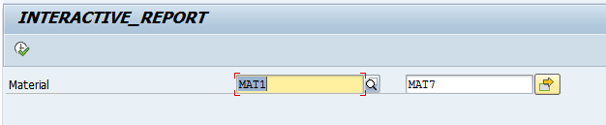

Step # 2. Prepare the Basic List (INDEX 0) fields from the MARA table.
Field names: MATNR, MBRSH, MTART and MEINS.

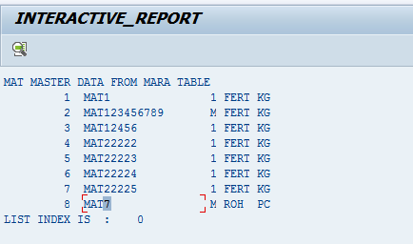

Step # 2. Prepare the First Secondary list (INDEX 1) fields from the MARC Table.
Field Names: MATNR and WERKS.

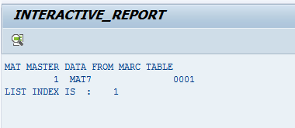

Step # 2. Prepare the Second Secondary list (INDEX 2) fields from the MAKT Table.
Field Names: MATNR, MAKTX and SPRAS.

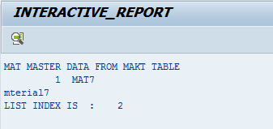

- Create an executable program to prepare the basic list and user command by using the menu painter.

Program Logic Hints:

- Declare the events in the report.
START-OF-SELECTION. END-OF-SELECTION. TOP-OF-PAGE. AT USER-COMMAND.

- Use the SET PF-STATUS to design the menu painter.

Reference T-Codes and Tables:

T-Codes: SE38 and MM03 Tables: MARA, MARC and MAKT.

Step # 1. Go SE38 T-Code and create an executable program. Input should be Materials range and it should be an obligatory.

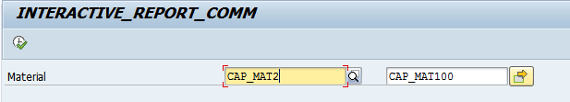

Step # 2. Display the PUSHBUTTONS , T-CODE and OTHER INFO by using the Application Tool bar (T-Code SE41 Menu Painter) in the report output.
Prepare the basic list data from MARA Table for MATNR, MBRSH , MTART and MEINS fields based on the select options.

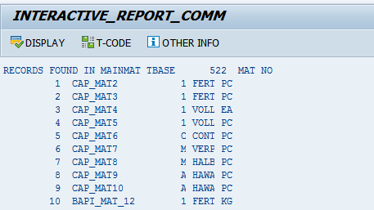

Step # 3. When user selects the DISPLAY Pushbutton, Get the data from MARC and MAKT tables based on the select options range by using the for all Entries Concept.

Display the following fields output:
MARC Table: MATNR, WERKS, PSTAT, LVORM, BSTMI and BSTMA.
MAKT Table: MATNR, SPRAS, MAKTX and MAKTG.

Step # 4. When user selects the T-Code Pushbutton, Call the transaction SE11.

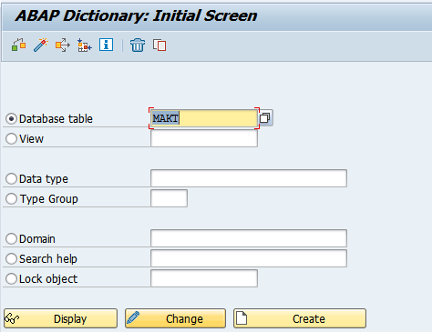

- Create a copy of the above assignment. Use the GET CURSOR Technique.
- Create an Interactive report by using the GET CURSOR Technique.

Reference T-Codes and Tables:

T-Codes: SE38 Tables: SCARR,SPFLI and SFLIGHT.

Display the basic list report with the following details from the SCARR,SPFLI and SFLIGHT table. Display only 25 records.
CARRID, CARRNAME, CONNID,COUNTRYFR, FLDATE, PRICE
Use For ALL entries for doing the above task.

If user clicks on CARRID, display the the following details SCARR TABLE.
CARRNAME, CURRCODE, URL

If user clicks on CONNID, display the the following details from SPFLI TABLE.
COUNTRYFR, CITYFROM, AIRPFROM

